Supplemental Information 1 for Fidino et al.

Examples of the lure and non-lure control used for this study.

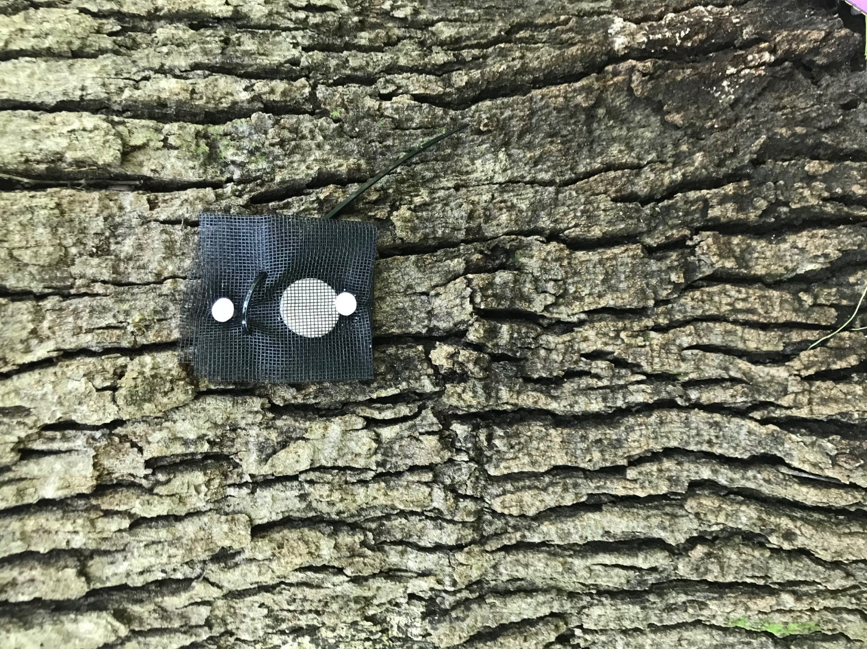

Figure S1. Example of the lure treatment used. The FAS disk is placed within a black mesh pouch, sealed with a zip tie, and then nailed to a tree.

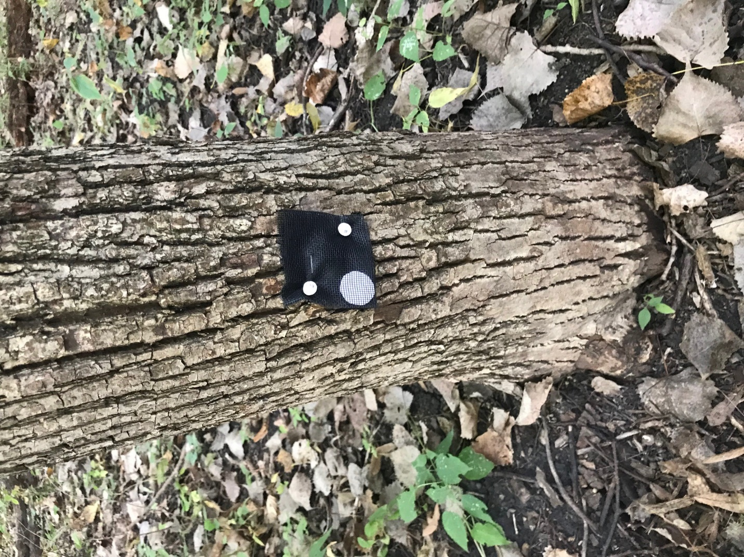

Figure S2. Example of the non-lure control. The circular cardstock is placed within a black mesh pouch, sealed with a single staple, and then nailed to a tree.